Skills challenge 1

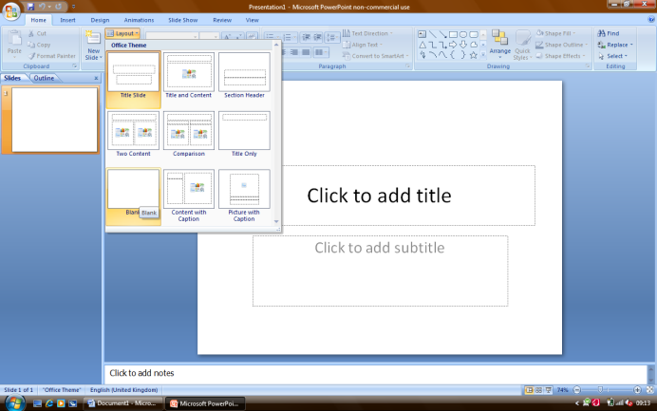Prepare your program
Open PowerPoint
Click on LAYOUT > BLANK

Choose your clipart
- Click on INSERT > PICTURE find a pictures from the clipart folder on the shared drive called CHALLENGE
- Choose a picture that you like from the folder.
- 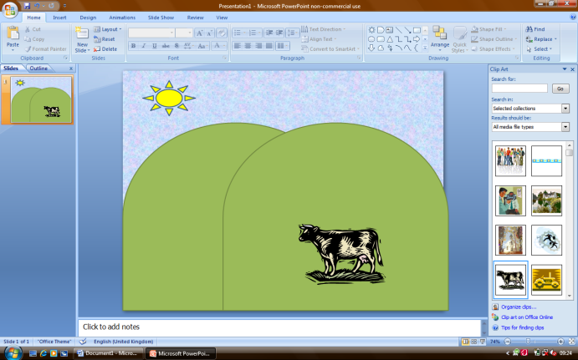You will make this picture move.

Add your background
- Create a background for your clipart, try and pick something suitable e.g. a sky with a flower for the bee, a field for the cow etc.
- You will need to use shapes INSERT>SHAPES
- You will need to change the colour of the shapes – click on FORMAT tab

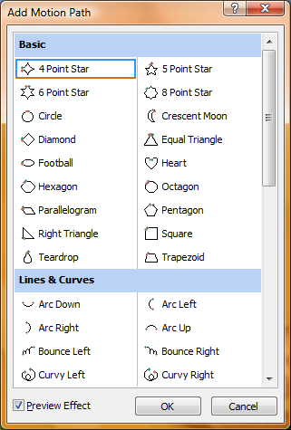Animate your clipart
- Click on ANIMATIONS > CUSTOM ANIMATION a bar should open to the right of your screen
- Then click ADD EFFECT>MOTION PATHS>MORE MOTION PATHS
- Choose a path

Test your animation
Save your animation – any name and then press F5 press the escape key to go back again.

Extension
Add more slides, draw your own motion path, create a story to go with the slides. Assign more than one path so your clipart moves round the screen. Can you make other things appear?

Skills challenge 2

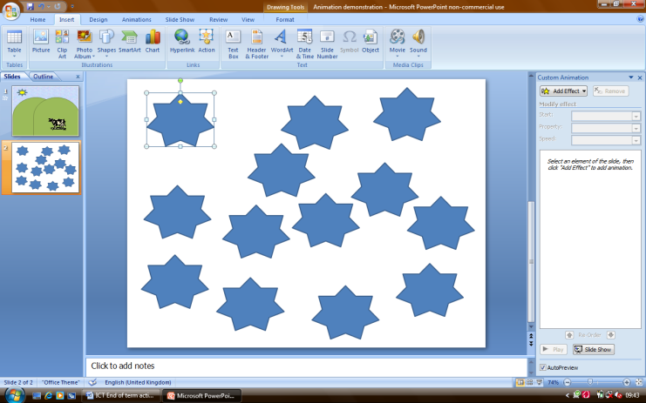Prepare your program
Open PowerPoint
Click on LAYOUT > BLANK

Choose your shape
Now use copy and paste to add lots of exact copies of your shape

Format your shapes
Click on the shape then click on FORMAT to change the colours

Animate your shapes
Click Control and A on the keyboard to select all stars (this is important)
Now using ANIMATION > ADD ANIMATION assign the following
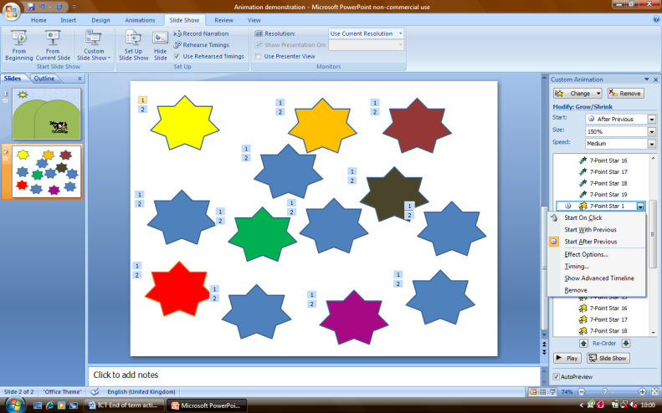 Entrance e.g. float
Emphasis e.g grow
Exit e.g pinwheel

Now from the animation task bar choose one animation and choose START AFTER PREVIOUS

Test your animation
Click on the F5 button on the keyboard to test and click on the escape key to come back to the program

Extension
Can you make your shapes stars form a shape (eg fly in to make a house shape)
Can you make your shapes all start in the middle and fly outwards like an explosion?

