So you think you can use the MS PAINT Program? 1
The Pizza Challenge
STAGE 1 SET UP YOU SHEET SO IT WILL PRINT PROPERLY
- Open PAINT from the shared drive
- FILE>PAGESETUP change orientation to landscape
- Now click on the edge of the white box and make it fill the screen
- FILE> PAGESETUP again and for to 1 page x 1 page
STAGE 2 SET UP YOUR PIZZA BASE
- Put in your pizza base use shapes tool.
- Create a COLOURS>EDIT COLOURS>DEFINE CUSTOM COLOURS to get the base colour just right. Use the paint pot to fill the shape.
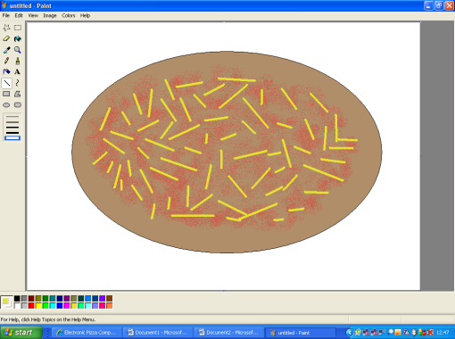
STAGE 3 ADD THE TOMATO SAUCE
- Create a custom colour for your tomato sauce
- Then use the airbrush spray tool
STAGE 4 ADD YOUR CHEESE
- Create a custom colour for your cheese
- Now use the line tool on thickest width to add your cheese all over
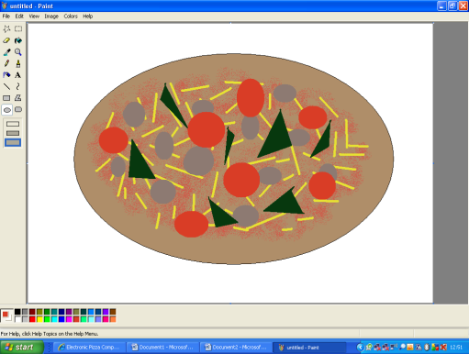
STAGE 5 ADD YOUR TOPPINGS
- Choose from; ham, mushroom, pineapple, peppers, meatballs, tuna, prawns, sweetcorn, pepperoni and anything else you like that isn’t listed here.
- Come up with creative ways of adding toppings
STAGE 6 PRINTING
- Print out a test sheet (black and white) when finished.
- If it prints OK print in colour

